PROGRAMMING IN JAVA
C01-AT3
NAME: POOJA SHREE K N
REG NO: 192572129

- Read the number of rooms, rate per room, and number of
nights. Calculate hotel cost and apply a long-stay discount for
more than five nights.

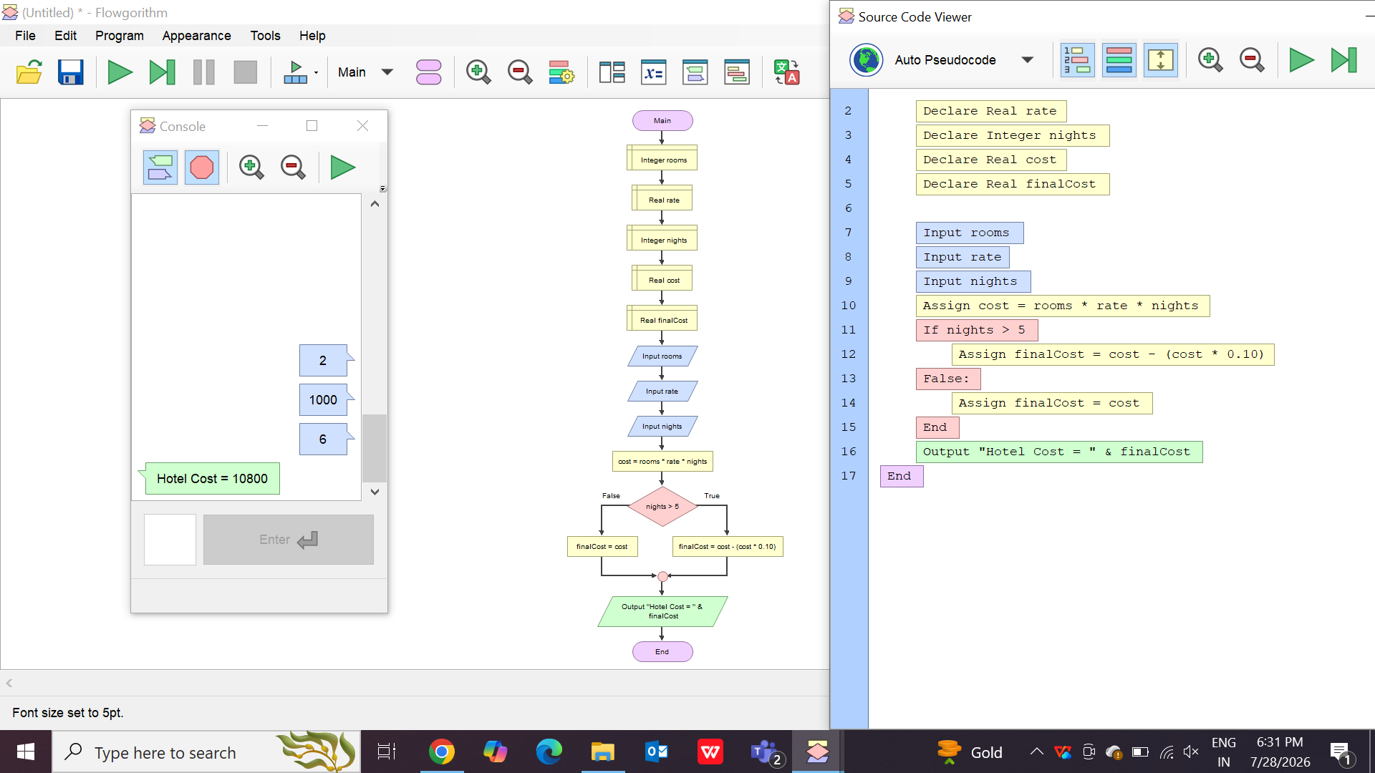

- Read N integers into an array and find all indices at which the value is greater than the overall array average.

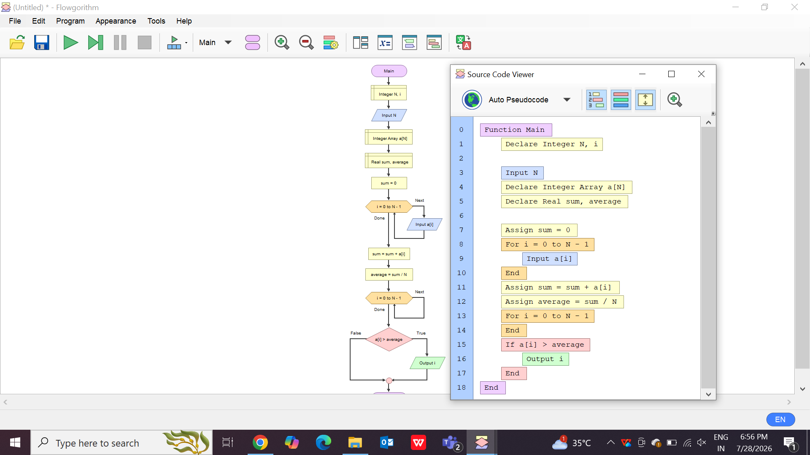

- Create a menu-driven unit-conversion flowchart using
separate functions for length, weight, and temperature
conversions.
